Model Investment Club of Northern Virginia (MicNOVA)
DC Chapter of Better Investing
Minutes (Draft) for the April 9, 2024 (Online Meeting)

Members Present (12): Sheryl Patterson, Arvind Krishna, Ty Hughes, Pat Onufrak, Patrick Smith, Gladys Henrikson, Andrew Ober, Paul O’Mara, Lisa Faustlin, Kathy Emmons, Baskar Arumugam, Jo Murphy
Members Absent (2): , Maskey Krishnarao, Janet Lewis,
Proxies for Members: None
Visitors/New Attendees Present (9): Lee Outlaw, Carol Cuddihy, Gene Close, Raj Sathyanarayana, Fred Beckman, Anne Bradley, Carmen Dudley, Atul Manacha, Patsy.

Baskar led the meeting, substituting for Janet who was ill. He welcomed guests including newcomers, stated the club’s purpose & objectives, displayed the BI Disclaimer and followed the meeting agenda.

- Secretary’s Report – Arvind
Meeting Minutes Report (3/12/2024) was presented by Arvind. No corrections were offered to the draft minutes. Members moved, seconded, and voted to approve the March minutes and file them in the Bivio Minutes folder.

- Treasurer’s Report – Gladys and Ty

Gladys presented the Treasurer’s Report, primarily the Club’s portfolio and cash positions as of April 8, 2024, shown in the in Bivio Valuation report. Members noted the club had $2,892.51 in cash. The report was accepted.

- Stock and Stock Watcher Rotation.
Members were assigned numbers and, as their number was called, chose their new stock from the MicNova Portfolio. The new assignments take effect for the May meeting. Please see the Updated Stock Watcher Table, below.

- Education & New Stock Presentation Timetable for 2024 –Baskar
Partners are encouraged to identify their 2024 Education and Stock Presentation titles for the next 3 months in advance, so that Carol Cuddihy can submit them onto our BI webpage.

- Education: “How to Complete an SSG for a Company with Negative Earnings” – by Baskar for Maskey
Baskar presented slides, adapted from an excellent June 2021 presentation by Better Investing’s Ken Kavula, on using the SSG tool to estimate sales and earnings when a company has reported a year of negative sales and/or earnings. The caveats are: the company had several years of positive sales and earnings before the negative year; there is evidence the company is recovering, and the person doing the estimates is confident the company is a going concern.

- New Stock Presentation: “Iradimed Corp” (Nasdaq - IRMD) – by Ty Hughes
Ty presented a new stock, Iradimed (IRMD), which is very small (< $1B) medical devices company. which makes a plastics-based Magnetic Resonance Imaging (MRI) compatible non-magnetic, intravenous (IV) infusion pump system and MRI compatible patient vital signs monitoring system. Non-magnetic MRI-compatible devices are sold to hospitals and acute care facilities in the US and internationally, and are deemed safer for patients and easier to handle by medical staff. Current PE is about 30 and is trading below its 5-year average PE (68). SSG analysis shows IRMD at $42 is a “Buy.” Ty estimated sales and profits at about 11%.

- Stock Watcher Quarterly Reports Presented:
There was 1 stock watchers’ report:
- ADBE - Kathy – Explained that ADBE had a dip in earnings because it paid the EU $1B for a failed acquisition. However, sales are strong. Her SSG says “Buy,” but it is already 7 of MicNova Portfolio

Stock Watchers Please place your updated Reports into Bivio. Also, please share the Online SSG with all MICNOVA members going forward

- Current MICNOVA Portfolio Review: by Ty
Ty made a comprehensive presentation of club’s Portfolio review as of April-2024, which included data from resources – BIVIO Net Asset Value Report; Performance Report (Investment Account Manager); Better-Investing Reports, Portfolio Evaluation Review Technique (PERT) Report and Summary; and Manifest Investing Dashboard. Small Cap & Mid Cap are coming up.
Overall Micnova portfolio performance:
YTD — 1.6% vs. 7.3% for S&P 500 • 1 year — 35.9% vs. 34.9% for S&P 500 • 3 years — 9.2% vs. 11.1% for S&P 500 • Since Sep 11, 2008 — 11.3% vs. 13.5% for S&P 500
Recommendations: We still have no small-cap stocks. Small cap is likely to outperform in the coming year. • Add quality small-cap companies with PAR > 15% • Take a hard look at WAL. TSCO, ADBE, and SSD

- Decision Buys/Sells: Partners voted for the following transactions in the affirmative.
04/09/2024/ | Sheryl moved, and Lisa seconded, that the club use its current cash to buy up to 68 shares of IRMED
Update, 04/10/2024: purchased 60 shares of IRMD at $41.36 per share* $2481.80
*Broker, Fidelity, would not allow us to spend more than 95% of cash on handl
- Member Questions and other Decisions: Partners - None

- Next Month Meeting Reminders – May 14, 2024:
Planning and Meeting Leader |  | Lisa
Education | Topic: | Arvind
New Stock Presentation | STOCK: | Patrick?
Stock Watcher Reports Due | Stock Watchers ( Please post studies in Bivio and share the Online SSG with all MicNOVA members):  - Google (Ty)  - Gentex  - SSD  - Visa  - Vertex  - Western Alliance Bancorp
Portfolio Reports |  | Ty
Watch List Reports |  | Sheryl

April 2024 BI and Community Events & Announcements:
Wed Apr 10 6-7pm ET | Mid-Michigan Inv Conference: Gaining Confidence  https://attendee.gotowebinar.com/register/1131153811139447131
Wed Apr 10 8-9pm ET | Mid-Michigan Inv Conference: Narrowing the Field  https://attendee.gotowebinar.com/register/8435003945781165654
Thr Apr 11 6-7pm ET | Mid-Michigan Inv Conference: The Contenders  https://attendee.gotowebinar.com/register/772183055880142941
Thr Apr 11 8-9pm | Mid-Michigan Inv Conference: Let’s talk stock panel  https://attendee.gotowebinar.com/register/2298799975465849440
Tue Apr 16 2024 07:30 - 09:00 PM  (Third Tuesdays of Month) | Money Matters Book Discussion. Book: The Coming Wave by Mustafa Salleman (about AI)  Online via GTM: You can also dial in using your phone.  United States: +1(646) 749-3122  One-touch: tel:+16467493122,,804623085#  Access Code: 804-623-085
Wed Apr 17 07:00 - 09:00 PM  Wed May 15 07:00 - 09:00 PM  (3nd Wednesdays of Month) | MCMC Monthly Meeting  https://global.gotomeeting.com/join/745127301  You can also dial in using your phone.  (For supported devices, tap a one-touch number below to join instantly.)  United States: +1 (872) 240-3311  - One-touch: tel:+18722403311,,745127301#  Access Code: 745-127-301
Thr April 18 2024 08:00 – 09;15 pm ET | Stock-up:: Portfolio Management  https://register.gotowebinar.com/register/6255025331266308440?source=event
Wed Apr 24 2024 08:00 -09:00 pm ET | Ticker Talk  https://register.gotowebinar.com/register/5079339538187265369?source=event
Tues Apr 30 2024 08:00 – 9:15pm ET | Manifest Investing Roundtable  https://attendee.gotowebinar.com/register/3251070504161567580

Schedule: New Stock Presentation, Planning and Monthly Meeting Chair
 | Name | Education | New Stock Presentation | Conduct MicNOVA Monthly Meeting | Conduct MicNOVA Planning Meeting
1 | Patterson, Sheryl | 7/9/24 | 03/11/24 | 12/12/23 | 12/5/23
2 | Hughes, James (Ty) | 1/9/24 | 04/09/24 | 10/8/24 | 10/1/24
3 | Krishnarao, Maskey | 2/13/24 | 01/14/25 | TBD | TBD
4 | Krishna, Arvind | 5/14/24 | 12/10/24 | 8/13/24 | 8/6/24
5 | Arumugam, Baskar | 4/09/24 | 2/11/25 | 6/11/24 | 6/4/24
6 | Henrikson, Gladys | 3/12/24 | 7/09/24 | 1/9/24 | 1/2/24
7 | Murphy, Josephine (Jo) | 8/13/24 | 6/11/24 | 7/9/24 | 7/2/24
8 | Emmons, Elinor (Kathy) | 9/10/24 | 11/12/24 | 9/10/24 | 9/3/24
9 | Smith, Patrick | 12/12/23 | 10/08/24 / 05/14/24 | 3/12/24 | 3/5/24
10 | Onufrak, Patricia | 6/11/24 | 8/13/24 | 2/13/24 | 2/6/24
11 | O’Mara, W. Paul | 11/12/24 | 09/10/24 | 11/5/24 | 11/12/24
12 | Lewis, Janet | 10/8/24 | TBD (5/14/24) | TBD | TBD
13 | Ober, Andrew | 12/10/24 | 3/12/24 | 1/9/24 | 1/2/24
14 | Faustlin, Lisa |  |  | 5/14/24 | 5/7/24

For Future Education Topics:
See BI Ticker Talk, Stock-Up, and Learning Modules for ideas
Next 3 Months - Reminders
June 2024 | New Stock |  | Jo Murphy
June 2024 | Education |  | Pat
Jul 2024 | New Stock |  | Gladys
Jul 2024 | Education |  | Sheryl
Aug 2024 | New Stock |  | Pat
Aug 2024 | Education |  | Jo Murphy

Schedule: Education Topics For 2024
Please go to BI Website’s Ticker Talk, Stock-Up, and Volunteer 4-Bits to find good topics for your Education Schedule. Provide your schedule and topic 3 months in advance.

MicNOVA Portfolio & New Stock Watchers: (Stock Reports due for upcoming May meeting are highlighted)

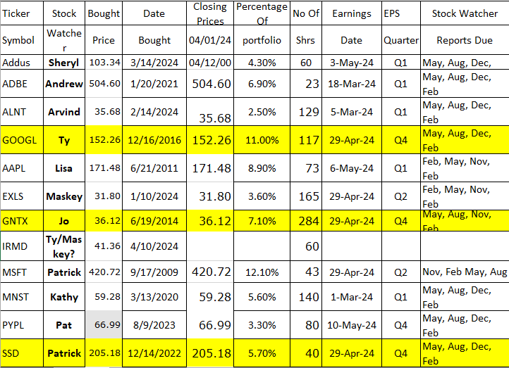
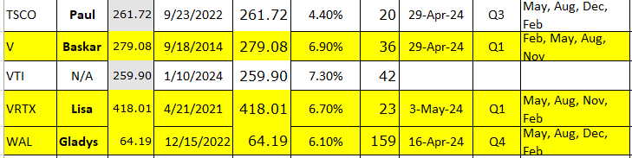

Meeting Adjourned: At 9 PM by Baskar
Minutes Submitted by Gladys Henrikson; Portfolio Stocks’ Earnings Calendar updated by Maskey Krishnarao

