MicNOVA Jun 2024 Meeting Agenda
Meeting Location | Online via Go-To Meeting
Meeting Date & Time | Jun 11 2024 07:00 PM - 09:00 PM
Online Meeting | https://global.gotomeeting.com/join/251997157  You can also dial in using your phone.  United States: +1 (312) 757-3121  Access Code: 251-997-157

MODEL INVESTMENT CLUB DISCLAIMER
• The information presented and discussed in this model club meeting is for demonstration and educational purposes only. The securities of companies referenced or featured in the meeting materials, presentation and discussion are for illustrative purposes only and are not to be considered endorsed or recommended for purchase or sale by BetterInvesting™ / National Association of Investors™. The views, opinions expressed and decisions made by club partners regarding the purchase and sale of stocks or other assets are those of the partner(s), and do not necessarily reflect the views and opinions of BetterInvesting. No recommendation to purchase or sell any stock, mutual fund, or other security referenced is being made on behalf of BetterInvesting.
• Securities discussed may be held by the club partners and presenters in their own personal portfolios or in those of their clients. BetterInvesting presenters and volunteers are held to a strict code of conduct that precludes benefiting financially from educational presentations or public activities via any BetterInvesting programs, events and/or educational sessions in which they participate. Any violation is strictly prohibited and should be reported to the CEO of BetterInvesting or the Director of Chapter Relations.
• This meeting may contain images of websites and products or services not endorsed by BetterInvesting. The presenter is not endorsing or promoting the use of these websites, products or services.
• We may record this session for our future use.

Agenda
07:00 - 07:05 PM | Welcome Regular Guests and First Time Visitors  Disclosure: Better Investing | Baskar
07:05 - 07:07 PM | Secretary’s Minutes | Arvind/Maskey
07:07 - 07:10 PM | Treasurer’s report | Gladys
07:10 - 07:15 PM | Announcement: BINC Celebrates Sheryl from DC Chapter | Gladys
07:15 - 07:35 PM | Education: Stocks Ideas from BINC 2024-Chicago (2 Stocks each in 2 mins each - no Judgements needed) - 10 Stocks | Gladys, Sheryl, Ty, Lisa, Jo
07:35 - 07:55 PM | New Stock Presentation: Air Product and Chemicals Inc (APD) | Jo
07:55 - 08:20 PM | Stock Watchers ( Please share the Online SSG with all MicNOVA members)  Portfolio:  - Addus (Sheryl)  - ALNT (Arvind)  - EXLS (Maskey)  - IRMD(Ty)  - MNST (Kathy) | Sheryl  Arvind  Maskey  Ty  Kathy
08:20 - 08:30 PM | Portfolio Review and Tools | Ty
08:30 - 08:45 PM | Decision: Buys and Sells | Partners
08:45 - 08:55 PM | Upcoming Events and Announcements | Baskar
09:00 | Adjourn | Baskar

2024 BI and Community Events & Announcements
Tue Jun 18 2024 07:30 - 09:00 PM  (Third Tuesdays of Month) | Money Matters Book Discussion. Podcast: featuring John Coates, Author of The Problem of Twelve: When a Few Financial Institutions Control Everything  Online via GTM: You can also dial in using your phone.  United States: +1(646) 749-3122  One-touch: tel:+16467493122,,804623085#  Access Code: 804-623-085
Wed Jun 19 07:00 - 09:00 PM  Wed Jul 09 07:00 - 09:00 PM  (3nd Wednesdays of Month) | MCMC Monthly Meeting  https://global.gotomeeting.com/join/745127301  You can also dial in using your phone.  (For supported devices, tap a one-touch number below to join instantly.)  United States: +1 (872) 240-3311  - One-touch: tel:+18722403311,,745127301#  Access Code: 745-127-301
Thu Jun 20 08:00-09:30 PM | Ticker Talk
Tue Jun 25 08:00-09:30 PM | Round Table
Mon Jul 1 2024 07:00 - 08:15 PM | Digging into BI Magazine  Registration URL: https://register.gotowebinar.com/rt/6574788583850753036  Webinar ID:729-893-259
Tue Jul 09 07:00 - 09:00 PM  (2nd Tuesdays of Month) | MicNOVA Monthly Meeting Online  https://global.gotomeeting.com/join/251997157  You can also dial in using your phone.  United States: +1 (312) 757-3121  Access Code: 251-997-157
Sat Jul 13 09:30 AM - 01:00 PM | Chapter Planning Meeting for 2024-25 - Online via GTM

Schedule: New Stock Presentation, Planning and Monthly Meeting Chair
 | Name | Education | New Stock Presentation | Conduct MicNOVA Monthly Meeting | Conduct MicNOVA Planning Meeting
1 | Patterson, Sheryl | TBD | 03/11/24 | 12/12/23 | 12/5/23
2 | Hughes, James (Ty) | 1/9/24 | 04/09/24 | 10/8/24 | 10/1/24
3 | Krishnarao, Maskey | 2/13/24 | 01/14/25 | TBD | TBD
4 | Krishna, Arvind | 5/14/24 | 12/10/24 | 8/13/24 | 8/6/24
5 | Arumugam, Baskar | 04/09/24 | 2/11/25 | 6/11/24 | 6/4/24
6 | Henrikson, Gladys | 3/12/24 | TBD | 1/9/24 | 1/2/24
7 | Murphy, Josephine (Jo) | 8/13/24 | 6/11/24 | 7/9/24 | 7/2/24
8 | Emmons, Elinor (Kathy) | 9/10/24 | 11/12/24 | 9/10/24 | 9/3/24
9 | Smith, Patrick | 12/12/23 | 10/08/24 / | 3/12/24 | 3/5/24
10 | Onufrak, Patricia | 7/9/24 | 8/13/24 | 2/13/24 | 2/6/24
11 | O’Mara, W. Paul | 11/12/24 | 05/14/24 | 11/5/24 | 11/12/24
12 | Lewis, Janet | 10/8/24 | 09/10/24 | TBD | TBD
13 | Ober, Andrew | 12/10/24 | 3/12/24 | 1/9/24 | 1/2/24
14 | Faustlin, Lisa | TBD | 07/09/24 | 5/14/24 | 5/7/24

Stock Watcher Reports
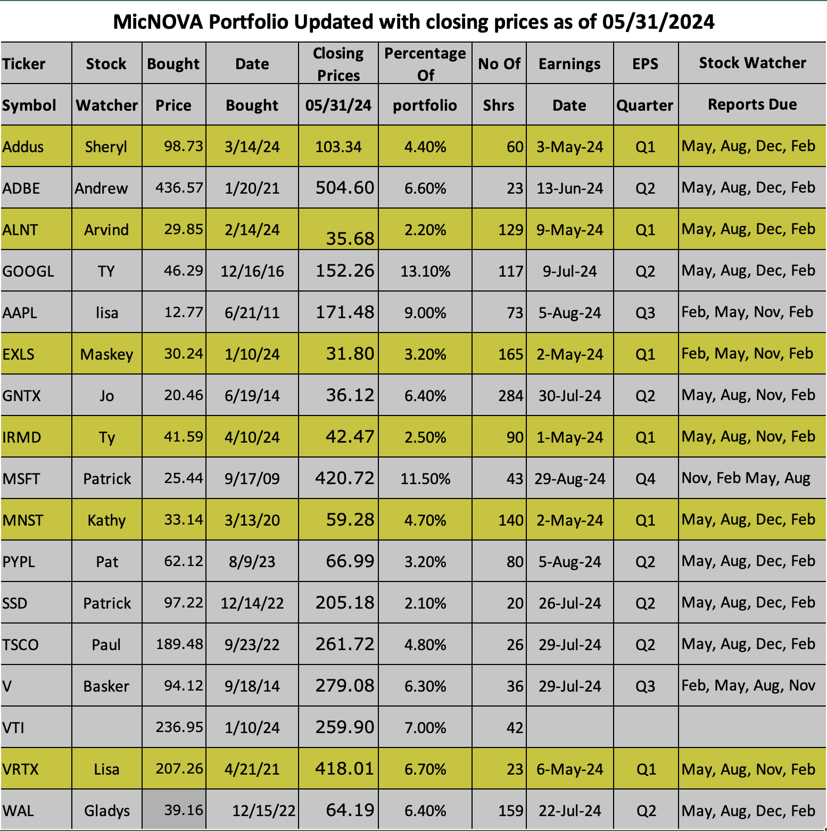
Lisa: New Stock (Jul 2024): Pfizer

