Model Investment Club of Northern Virginia (MicNOVA)
DC Chapter of Better Investing
Minutes for the January 09, 2024 (Online Meeting)

Members Present: Sheryl Patterson, Arvind Krishna, Ty Hughes, Pat Onufrak, Jo Murphy, Patrick Smith, , Maskey Krishnarao, Baskar Arumugam, Gladys Henrikson, Andrew Ober, Kathy Emmons, Janet Lewis
Members Absent: Paul O’Mara
Proxies for Members: None
Visitors/New Attendees Present: Fred Beckmann, Paul Doku, Atul Manocha, Carol Cuddihy, Carmen Dudley, Lisa Faustin, Janel, Gene Close, Anne Bradley, Raj Sathyanarayana, John 1234

Andrew led the meeting. He welcomed guests including newcomers, stated the club’s purpose & objectives, displayed the BI Disclaimer and followed the meeting agenda.

- Secretary’s Report – Arvind
Dec 12, 2023 Meeting Minutes report was presented by Arvind. No corrections were addressed in the draft minutes. Ty made the motion to accept minutes as-presented. Sheryl seconded. The final Minutes are now posted in the Bivio folder.

- Treasurer’s Report – Gladys and Ty
Gladys presented the Treasurer’s Report, which was accepted. The report indicated Cash Account basis: $23,872 and Total Securities & Cash Account basis: $76,463. Sheryl made the Motion to accept the report, which passed without objections. The Treasurer’s report is filed in Bivio.
Gladys, informed that Micnova taxes are due on March 15 and she requested for some volunteers to assist her in performing the annual audit of Micnova accounts prior to filing the Federal taxes. Jo, Arvind, Andrew and Patrick volunteered to assist in the audit process.
Ty, mentioned that member’s tax allocations for the year 2023 are now filed in Bivio and everyone is encouraged to review their individual accounts for accuracy.

- Education & New Stock Presentation Timetable for 2024 – Sheryl
Partners are requested to identify their 2024 Education and Stock Presentation titles for the next 3 months in advance, so that Carol Cuddihy can submit them onto our BI webpage.

- Education: “Estimating P/Es during SSG analysis of a Stock” - by Ty
Ty presented an educational Session reviewing the process and data used to estimate High & Low P/Es that are input into the SSG tool for stock analysis. Ty discussed internal & external sources to research historic P/Es. He explained by examples how PEs reflect investor sentiments. Ty discussed three variables that affect P/Es – EPS Growth, Dividend Yield, and changes in P/E ratios over the last five years. The presentation made by Ty is filed in the Public Files on the Bivio.

- New Stock Presentation: “EXL Services” (Nasdaq - EXLS) - by Baskar
Baskar presented an analysis of new stock EXLS, in the Technology sector (IT Services Industry), a medium size holding company. ExlS is a business process management company - provides digital operations & analytical services to clients driving enterprise-scale business transformation initiatives that leverage company's deep expertise in analytics, AI, ML and cloud. EXLS offers business process outsourcing and automation services, and data-driven insights to customers in multiple industries. EXLS Business operates through four segments: Insurance, Healthcare, Emerging, Analytics. Major source of the company's revenue is earned in USA, and more than half of it comes from Analytics segment.
SSG shows “Buy” (Buy range $24.5 - $$32.1). Price on 1/8/24 was $30.16. MI Rating for Quality is 93.

- Stock Watcher Quarterly Reports Presented:
There were 4 stock watchers’ reports:

- Adobe (ADBE) - Kathy – Hold; At $586.20, currently 9% of our portfolio
- Monster (MNST) - Gladys – Recommended Buy
- Apple (AAPL) - Paul (presented by Gladys since Paul absent) – Hold
- Paypal (PYPL) - Baskar- Hold/Buy; Good company to look further into; Buy Range ($53.3 - $73.9)
Stock Watchers (Please share the Online SSG with all MICNOVA members going forward)

- Watch List Stocks Review – by Ty
Ty recommended to consider the Average P/E value for the SSG Rate of Return projections for each stock.
Ty also presented an SSG for Allient (ALNT), a small CAP. SSG shows “Buy”. Current Price is $28.17 on 01/05/2024. Put ALNT on a Watch List. Baskar recommended to compare EXLS with MKSI & EPAM for consideration to buy.
Sheryl is also looking at Technoglass to be considered on the Watch List. Recommended a presentation next month in February.

- Current MICNOVA Portfolio Review: by Ty
Ty made a comprehensive presentation of club’s Portfolio review as of Jan 09 2024, which included data from resources – BIVIO Net Asset Value Report; Performance Report (Investment Account Manager); Better-Investing Reports, Portfolio Evaluation Review Technique (PERT) Report and Summary; and Manifest Investing Dashboard. Overall portfolio (01/01/2023 – 01/08/2024) Annualized IRR – 33.72% (Ref. S&P 500 – 23.1%), doing well this year.
MICNOVA Returns as of Dec 31 – 2023 are: for 1 year — 36.6% vs. 26.7% for S&P 500; for 3 years — 10.7% vs. 10.3% for S&P 500; Since Sep 11, 2008— 11.3% vs. 13.1% for S&P 500.
According to MI – High PAR stocks are: GNTX, GNRC, Goggle, Tractor Supply, MNST, and PayPal. Low PAR Stocks are: ADBE and VRTX.

- Decision Buys/Sells: Partners
The MICNOVA members voted to buy the following stocks and ETFs:
- EXLS - $5000 (165 shares at $30.33/share)
- Paypal -$1500 (24 shares at $61.30/share.)
- Gentex -$2000 (63 shares at 31.96/share)

Sheryl made the motion to put excess cash currently available in the MICNOVA treasury into VTI (ETF). Motion passed (except objections from Pat) and we executed sale for available $10000 (42 shares of VTI -ETF at $237.35/share).

- Member Questions and other Decisions: Partners
None

- Next Month Meeting Reminders – February 13, 2024:
Education | Topic: | Maskey
New Stock Presentation | STOCK: | Sheryl
Stock Watcher Reports Due | Stock Watchers ( Please share the Online SSG with all MicNOVA members):  - GNTX  - MSFT  - V  - WAL | Maskey  Janet  Patrick  Sheryl
Portfolio Reports |  | Ty
Watch List Reports |  | Sheryl

2024 BI and Community Events & Announcements:
Thur Jan 11 2024 07:00 – 08:15 PM | Stock-up: Is this SSG reasonable?
Tue Jan 16 2024 07:30 - 09:00 PM  (Third Tuesdays of Month) | Money Matters Book Discussion Book: One Up on Wall Street by Peter Lynch  Online via GTM: You can also dial in using your phone.  United States: +1(646) 749-3122  One-touch: tel:+16467493122,,804623085#  Access Code: 804-623-085
Wed Jan 17 07:00 - 09:00 PM  Wed Feb 21 07:00 - 09:00 PM  (3nd Wednesdays of Month) | MCMC Monthly Meeting  https://global.gotomeeting.com/join/745127301  You can also dial in using your phone.  (For supported devices, tap a one-touch number below to join instantly.)  United States: +1 (872) 240-3311  - One-touch: tel:+18722403311,,745127301#  Access Code: 745-127-301
Thur Jan 25 2024 08:30 – 09:30 PM | Ticker Talk
Fri Feb 2 2024 08:00 - 09:00 PM | DC Chapter Director Meeting
Mon Feb 5 2024 07:00 - 08:15 PM | Digging into BI Magazine  Registration URL: https://register.gotowebinar.com/rt/6574788583850753036  Webinar ID:729-893-259
Tue Feb 13 07:00 - 09:00 PM  (2nd Tuesdays of Month) | MicNOVA Monthly Meeting Online  https://global.gotomeeting.com/join/251997157  You can also dial in using your phone.  United States: +1 (312) 757-3121  Access Code: 251-997-157

Schedule: New Stock Presentation, Planning and Monthly Meeting Chair
 | Name | Education | New Stock Presentation | Conduct MicNOVA Monthly Meeting | Conduct MicNOVA Planning Meeting
1 | Patterson, Sheryl | 5/14/24 | 2/13/24 | 12/12/23 | 12/5/23
2 | Hughes, James (Ty)* | 1/9/24 | 04/9/24 | 10/8/24 | 10/1/24
3 | Krishnarao, Maskey | 2/13/24 | 12/12/23 | 5/14/24 | 5/7/24
4 | Krishna, Arvind | 7/9/29 | 11/14/23 | 8/13/24 | 8/6/24
5 | Arumugam, Baskar | 9/10/24 | 1/9/24 | 6/11/24 | 6/4/24
6 | Henrikson, Gladys | TBD | 7/9/24 | 1/9/24 | 1/2/24
7 | Murphy, Josephine(Jo)* | 8/13/24 | 6/11/24 | 7/9/24 | 7/2/24
8 | Emmons, Elinor(Kathy) | 4/9/24 | TBD | 9/10/24 | 9/3/24
9 | Smith, Patrick | 12/12/23 | 10/8/24 | 3/12/24 | 3/5/24
10 | Onufrak, Patricia | 6/11/24 | 8/13/24 | 2/13/24 | 2/6/24
11 | O’Mara, W. Paul | 11/12/24 | 09/10/24 | 11/5/24 | 11/12/24
12 | Lewis, Janet | 3/12/24 | 5/14/24 | 4/9/24 | 4/2/24
13 | Ober, Andrew | 10/8/24 | 3/12/24 | 1/9/24 | 1/2/24

For Future Education Topics:
See BI Ticker Talk, Stock-Up, and Learning Modules for ideas
Next 3 Months - Reminders
Mar 2024 | New Stock |  | Andrew
Mar 2024 | Education |  | Janet
Apr 2024 | New Stock |  | Ty
Apr 2024 | Education |  | Kathy
May 2024 | New Stock |  | Janet
May 2024 | Education |  | Sheryl

Schedule: Education Topics For 2024
Please go to BI Website’s Ticker Talk, Stock-Up, and Volunteer 4-Bits to find good topics for your Education Schedule. Provide your schedule and topic 3 months in advance.

MicNOVA Portfolio & Stock Watchers: Updated closing prices as of January 08-2024

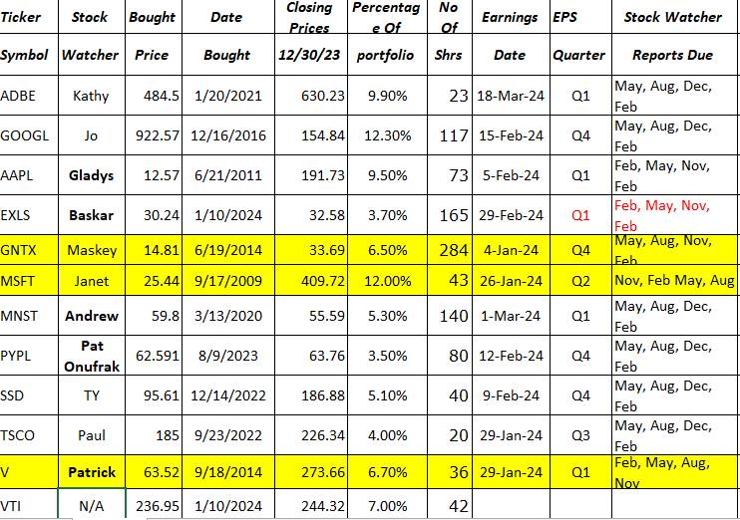

Meeting Adjourned: At 9 PM by Andrew
Minutes Submitted by Arvind Krishna; Portfolio Stocks’ Earnings Calendar updated by Maskey Krishnarao

