Model Investment Club of Northern Virginia (MicNOVA)
DC Chapter of Better Investing
Minutes for the September 12, 2023 (Online Meeting)

Members Present: Sheryl Patterson, Arvind Krishna, Ty Hughes, Gladys Henrikson, Paul O Mara, Janet Lewis, Pat Onufrak, Jo Murphy, Maskey Krishnarao, Patrick Smith, Baskar Arumugam, Kathy Emmons
Members Absent:
Proxies for Members: None
Visitors/New Attendees Present: Andrew, Erica, Carol Cuddihy, Susan Garrett, Lisa Faustin, Lee Outlaw, Carmen Dudley, Allan Foster, Robert Beaty

Kathy Emmons acted as the meeting lead. She welcomed guests including newcomers and led the meeting. She then started the meeting by explaining the club’s purpose & objectives, displayed the BI Disclaimer and explained all the clauses and stipulations.

- Secretary’s Report – Arvind
August 08, 2023 Meeting Minutes report was presented by Arvind. No corrections were addressed in the draft minutes. Jo made the motion to accept minutes, which was seconded. The final Minutes as accepted are now posted in the Bivio folder.

- Treasurer’s Report – Gladys
Gladys presented the Treasurer’s Report, which was accepted. The report indicated availability of $1500+ cash. A Motion was made to accept Treasurer’s Report, which passed. Final Treasurer’s report is filed in Bivio. Pat requested for the Fidelity accounts information to be provided again for making the required monthly contributions to the MICNOVA’s Portfolio now being managed by Fidelity.

- Education & New Stock Presentation Timetable for 2023 - 2024 – Sheryl & Gladys
Partners are requested to identify their 2023 - 2024 Education and Stock Presentation titles for the next 3 months in advance, so that Carol Cuddihy can submit them onto our BI webpage.

- Education: - by Sheryl
Sheryl presented an excellent Educational session on “Quality Matters First - Total Return vs. the
Upside/Downside Ratio”. This presentation authored by Cy Lynch, Chair, Better Investing Board of Directors was initially presented at the 9th Annual Georgia Chapter Education Fair, August 19, 2023. This session focused on learning: Investing in high quality companies, selling at good values – Quality matters first –Value matters most, and is best measured by projected total return. It also emphasized to focus on projected total return for overall portfolio, not just individual stocks.

- New Stock Presentation: HEICO (NYSE) – by Paul
HEICO is a 65 yrs. old high technology electronics company operating in aerospace, industrial, and defense sectors, headquartered in Hollywood, FL. And at other locations around the world. HEICO’s annual revenue in 2023 is $2.2B. HEICO has gone through an impressive growth organically and through acquisitions. HEICO’s current price on 9/8/23 was $164.41. Its 52 Week high price is $182.18 and low price at $132.82. SSG analysis showed “HOLD”. Recommendation is to consider buying below price of $153.1. Value Line’s LT forecast is, “HEICO’s 3 – 5 years prospects are worthwhile.

- Stock Watcher Quarterly Reports Presented:
There were 5 stock watchers’ reports:
Simson Manufacturing (SSD) – Ty - “Hold”
EPAM – Baskar – Recommend “Hold”
TSCO – Paul – “Hold”
VRTX - Arvind – VRTX’s stock has done well during the past year. Every quarter it keeps gaining in value and keeping up with the market. Current SSG analysis shows “Hold”. Investors are enthusiastically awaiting for FDA’s Fast Track approval of VRTX’s two major disease therapies undergoing biologics right now and for FDA’s announcements on: Dec 08 – 2023 for Sickle Cell Treatment and March 30 – 2024 for Beta Thalassemia.
WAL – Sheryl – SSG analysis “HOLD”
Stock Watchers (Please share the Online SSG with all MICNOVA members going forward)

- Watch List Stocks Review – by Ty
Ty recommended to challenge EPAM and NVEE and watch closely – GNRC and CLFD, whether or not we should hold them or buy more. Look for positive revenue trends over the next two quarters - If positive, consider adding to the position - If negative, challenge.

- Current MICNOVA Portfolio Review: by Ty
Ty made a comprehensive presentation of club’s Portfolio review as of 9/12/2023, which included data from resources – BIVIO Net Asset Value Report; Performance Report (Investment Account Manager); Better-Investing Reports, Portfolio Evaluation Review Technique (PERT) Report and Summary; and Manifest Investing Dashboard. Stocks that have performed badly are: EPAM, CLFD and NVEE. Ty also reviewed our Portfolio from Manifest-Investing for stocks with projected high and low PAR values – Adobe, Apple and VRTX.

- Decision Buys/Sells: Partners
The Club made the MOTION to sell all EPAM shares and put the proceeds along with available cash to conduct the following transactions. The motion passed and the club bought and sold stocks as follows:
- Bought 31 shares of GNTX at $31.78 ($985.18)
Bought 6 shares of V at $247.15 ($1,482.90)
Sold 13 shares of EPAM at $261.71 ($3,402.20)

- Member Questions and other Decisions: None

- Next Month Meeting Reminders – October 10, 2023:
Education | Topic: Using the BI Stock Screener to find Great Stocks in Targeted Industries | Gladys
New Stock Presentation | STOCK: Cummins Inc (Ticker: CMI) | Patrick
Stock Watcher Reports Due | Stock Watchers ( Please share the Online SSG with all MicNOVA members):  - MNST | Gladys
Portfolio Reports |  | Ty
Watch List Reports |  | Sheryl

2023 BI and Community Events & Announcements

Tue Sep 19 2023 07:30 - 09:00 PM  (Third Tuesdays of Month) | Money Matters Book Discussion. Book: Against the Gods: The Remarkable Story of Risk by Peter Bernstein  Online via GTM: You can also dial in using your phone.  United States: +1(646) 749-3122  One-touch: tel:+16467493122,,804623085#  Access Code: 804-623-085
Wed Sep 20 07:00 - 09:00 PM  Wed Oct 18 07:00 - 09:00 PM  (3nd Wednesdays of Month) | MCMC Monthly Meeting  https://global.gotomeeting.com/join/745127301  You can also dial in using your phone.  (For supported devices, tap a one-touch number below to join instantly.)  United States: +1 (872) 240-3311  - One-touch: tel:+18722403311,,745127301#  Access Code: 745-127-301
Fri Oct 6 2023 08:00 - 09:00 PM | DC Chapter Director Meeting
Mon Oct 2 2023 07:00 - 08:15 PM | Digging into BI Magazine  Registration URL: https://register.gotowebinar.com/rt/6574788583850753036  Webinar ID:729-893-259
Tue Oct 10 07:00 - 09:00 PM  (2nd Tuesdays of Month) | MicNOVA Monthly Meeting Online  https://global.gotomeeting.com/join/251997157  You can also dial in using your phone.  United States: +1 (312) 757-3121  Access Code: 251-997-157
Sat Oct 28 09:30 - 03:30 PM | SSG Class Part 1 - Online Only.
Sat Nov 4 09:30 - 03:30 PM | SSG Class Part 2 - Online Only
Oct 18 - 22 2023 (different days and times) | San Francisco Chapter - 3 Fall Seminars. Please go to San Francisco Chapter Events on BI Website to register  - “Using Better Investing Online Tool to make me a better investor”  - “VISA - Is this a stock for you”  - “3 tools to enhance investing skills”
Beginning Sep 2023 - Every 2nd Sat 09:30 AM - 11:45 AM | “Learn to Earn - Series” each month. Florida Chapter presents.

Schedule: New Stock Presentation, Planning and Monthly Meeting Chair
 | Name | Education | New Stock Presentation | Conduct MicNOVA Monthly Meeting | Conduct MicNOVA Planning Meeting
1 | Patterson, Sheryl | 5/9/23 | 2/13/24 | 12/12/23 | 12/5/23
2 | Hughes, James (Ty)* | 1/9/24 | 04/11/23 | 10/10/23 | 10/3/23
3 | Krishnarao, Maskey | 2/13/24 | 12/12/23 | 5/9/23/  Baskar | 5/2/23  Jo
4 | Krishna, Arvind | 7/11/23 | 11/14/23 | 8/8/23 | 8/1/23
5 | Arumugam, Baskar | 9/12/23 | 1/9/24 | 6/13/23 | 6/3/23
6 | Henrikson, Gladys | 10/10/23 | 7/11/23 | 1/9/24 | 1/2/24
7 | Murphy, Josephine(Jo)* | 8/8/23 | 6/13/23 | 7/11/23 | 7/4/23
8 | Emmons, Elinor(Kathy) | 4/11/23 | 3/12/24 | 9/12/23 | 9/5/23
9 | Smith, Patrick | 12/12/23 | 10/10/23 | 3/12/24 | 3/5/24
10 | Onufrak, Patricia | 6/13/23 | 8/08/23 | 2/13/24 | 2/6/24
11 | O’Mara, W. Paul | 11/14/23 | 09/12/23 | 11/14/23 | 11/7/23
12 | Lewis, Janet | 3/12/24 | 5/9/23 | 4/11/23 | 4/4/23

For Future Education Topics:
See BI Ticker Talk, Stock-Up, and Learning Modules for ideas
Next 3 Months - Reminders
Nov 2023 | Education |  | O’Mara, W. Paul
Nov 2023 | New Stock |  | Arvind
Dec 2023 | Education |  | Patrick Smith
Dec 2023 | New Stock |  | Maskey
Jan 2024 | New Stock |  | Baskar
Jan 2024 | Education |  | Ty

Schedule: Education Topics For 2023
Please go to BI Website Ticker Talk to find the best topics for your Education Schedule. Come up with ideas and provide your schedule and topic next month

MicNOVA Portfolio and Stock Watchers: Updated with closing prices as of 09/30/2023

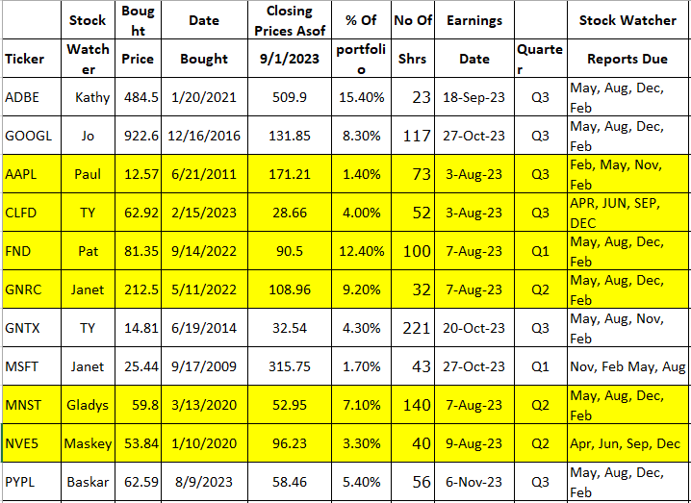
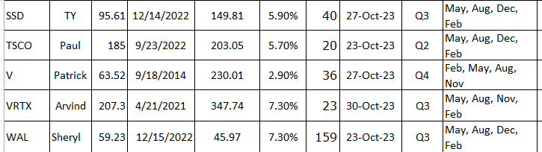

Meeting Adjourned: At 9 PM by Kathy
Minutes Submitted by Arvind Krishna; Portfolio Stocks’ Earnings Calendar updated by Maskey Krishnarao

