Model Investment Club of Northern Virginia (MicNOVA)
DC Chapter of Better Investing
Minutes for the June 13, 2023 (Online Meeting)

Members Present: Sheryl Patterson, Arvind Krishna, Ty Hughes, Gladys Henrikson, Paul O Mara, Kathy Emmons, Janet Lewis, Baskar Arumugam, Pat Onufrak, Jo Murphy, Maskey Krishnarao
Members Absent: Patrick Smith
Proxies for Members: None
Visitors/New Attendees Present: Anne Bradley, Fred Beckman, Lee Outlaw, Carol Cuddihy, Carmen Dudley, Ray Woods, Atul Manocha, Hien Nguyen

Baskar acted as the meeting lead. He welcomed guests including newcomers and led the meeting. He then started the meeting by explaining the club’s purpose & objectives, displayed the BI Disclaimer and explained all the clauses and stipulations.

- Secretary’s Report – Arvind
My 09, 2023 Meeting Minutes report was presented by Arvind. No corrections were addressed in the draft minutes. Sheryl made the motion to accept minutes, which was seconded. The final Minutes as accepted are now posted in the Bivio folder.

- Treasurer’s Report – Gladys
Gladys presented the Treasurer’s Report, which was accepted. The report indicated availability of $2,255 cash and $122,809 in securities and cash account. A Motion was made to accept Treasurer’s Report, which passed. Final Treasurer’s report is filed in Bivio.
In addition, Gladys pointed out some club limitations in using the new Schwab account. For example, stocks cannot be transferred to individual (withdrawing) partners, but cashed out and moved to a club bank account, from which the treasurer would write a check and mail it to the individual. She said she would initiate a search into alternative brokerages, such as Fidelity and Siebert. In the meantime, Gladys encouraged partners to resume sending their monthly contributions into the Schwab account (instructions filed in Bivio). If/when we move to another brokerage our entire account plus cash will be transferred. Further instructions regarding monthly deposits will be emailed to all the partners by Gladys.

- Education & New Stock Presentation Timetable for 2023 – Baskar/ Sheryl/Gladys
Partners are requested to identify their 2023 Education and Stock Presentation titles for the next 3 months in advance, so that Carol Cuddihy can submit them onto our BI webpage.

- Education: - by Pat Onufrak
Pat presented "What I Wish I Would've Asked About Stock Inheritance: Passing Along Our Wealth"
Her presentation on Family Estate Planning considerations invited people to think carefully about how to pass stock onto one's heirs, such as perhaps transferring the stocks rather than selling them, and writing a letter to the beneficiaries sharing such information as the person's investment strategy and offering advice in pursuing this strategy. Pat's full presentation is stored in Bivio under Education/2023.
.
- New Stock Presentation: FACTSET (FDS) – by Jo Murphy
Jo presented Factset Research Systems, Inc. (FDS), a medium size financial sector and analytics company in the financial services sector. It's a fascinating growth company, which Value Line projects to grow between 10-15% over the next 5 years, and is financially rated an A+. It has worldwide company customers, who largely pay for subscriptions. Jo's analysis showed that the company at $388 was slightly overvalued (SSG Buy Range $265 - $340.6) from Morningstar's assessed Fair Value of $365. The Club voted to place FDS on its Watch List, and hope for entry at a lower price point.

- Stock Watcher Quarterly Reports Presented:
There were five stock watchers reports:
EPAM – Baskar – Recommend “Hold” although SSG shows BUY;
Floor & Decor (FND) -Pat - Hold;
Generac (GNRC) - Ty – “Hold” for Another Quarter then re-evaluate; SSG indicated GNRC in the BUY range.
Simpson Manufacturing, Inc (SSD) - Ty – “Hold”;
Vertex (VRTX) - Arvind – SSG shows “Hold” although club should consider “Buy” more from a long term investing standpoint. VRTX has a bright LT future if new drug therapy (for sickle cell anemia) trials undergoing right now are successful and FDA approves the application.
Stock Watchers (Please share the Online SSG with all MICNOVA members going forward)

- Watch List Stocks Review – by Gladys
Ty recommended to put new stock presented FDS on the Watch List, since it is a good stock. Gladys even mentioned to include AVNET in the Watch List, but no final decision was made.

- Current MICNOVA Portfolio Review: by Ty
Ty presented performance of our Portfolio - slightly above the S&P 500 performance; and sorted our Watch list by Projected Average Return. He believes the club should trim its watch list. There were no compelling "buy" stocks at this time.

- Decision Buys/Sells: Partners
The Club decided to hold off buying and selling more stocks until we had more cash, from partner contributions, in the brokerage account.

- Member Questions and other Decisions - Between June and July Meetings:
Brokerage Change:
Gladys emailed, to the Partners, a summary of Pros and Cons of choosing a Club Brokerage. (Her pros and cons paper is filed in Bivio.) She asked the members to vote on the choices by Monday, June 26. Gladys subsequently heard from all Partners who chose moving to Fidelity, (which entailed the least paperwork and synched with both Bivio and MyICLUB accounting services) over remaining at Schwab or moving to Siebert.
Updated Partnership Agreement:
Gladys obtained the Fidelity Investment Cash-Club Account Application to open a new club account . This application requires the signature of all Partners plus a current, and signed, Partnership Agreement.
Since the existing Partnership Agreement was out of date, and deferred to the Operating Procedures for some items (such as transferring stock to withdrawing members), Gladys incorporated those key provisions into the new (June 26 2023) Partnership Agreement and circulated it for comment to members. No members objected to the changes and will sign the updated Partnership Agreement at the same time as they sign the Fidelity Investment Cash-Club Account Application (Between June27-29.) Arvind Krishna, who has personal accounts at Fidelity, is helping to facilitate this new account application.

- Next Month Meeting Reminders – July 11, 2023:
Education | - Topic: Fundamental Analysis vs. Technical Analysis for Stock Valuations | Arvind
New Stock Presentation | STOCK: Paychex (Ticker: PAYX) | Gladys
Stock Watcher Reports Due | Stock Watchers ( Please share the Online SSG with all MicNOVA members):
Portfolio Reports |  | Ty
Watch List Reports |  | Sheryl

2023 BI and Community Events & Announcements

Wed Jun 21 07:00 - 09:00 PM  Wed Jul 19 07:00 - 09:00 PM  (3nd Wednesdays of Month) | MCMC Monthly Meeting  https://global.gotomeeting.com/join/745127301  You can also dial in using your phone.  (For supported devices, tap a one-touch number below to join instantly.)  United States: +1 (872) 240-3311  - One-touch: tel:+18722403311,,745127301#  Access Code: 745-127-301
Mon Jul 10 2023 07:00 - 08:15 PM | Digging into BI Magazine  Registration URL: https://register.gotowebinar.com/rt/6574788583850753036  Webinar ID:729-893-259
Sat Jun 24 2023 10:30 am - 1:00 pm ET | DC Chapter Annual Meeting with Doug Gerlach - Online  https://meet.goto.com/114623005  You can also dial in using your phone.  (For supported devices, tap a one-touch number below to join instantly.)  United States: +1 (646) 749-3122  - One-touch: tel:+16467493122,,114623005#  Access Code: 114-623-005
Tue Jul 11 07:00 - 09:00 PM  (2nd Tuesdays of Month) | MicNOVA Monthly Meeting Online  https://global.gotomeeting.com/join/251997157  You can also dial in using your phone.  United States: +1 (312) 757-3121  Access Code: 251-997-157
Tue Jul 18 2023 07:30 - 09:00 PM  (Third Tuesdays of Month) | Money Matters Book Discussion. Book: Two and Twenty: How the Masters of Private Equity Always Win by Sachin Khajuria  Online via GTM: You can also dial in using your phone.  United States: +1(646) 749-3122  One-touch: tel:+16467493122,,804623085#  Access Code: 804-623-085
Sat Jul 15th 2023 09:30 - 02:30 | DC Chapter Annual Planning Meeting - Online ONLY

Schedule: New Stock Presentation, Planning and Monthly Meeting Chair
 | Name | Education | New Stock Presentation | Conduct MicNOVA Monthly Meeting | Conduct MicNOVA Planning Meeting
1 | Patterson, Sheryl | 5/9/23 | 2/13/24 | 12/12/23 | 12/5/23
2 | Hughes, James (Ty)* | 1/9/24 | 04/11/23 | 10/10/23 | 10/3/23
3 | Krishnarao, Maskey | 2/13/24 | 12/12/23 | 5/9/23/  Baskar | 5/2/23  Jo
4 | Krishna, Arvind | 7/11/23 | 11/14/23 | 8/8/23 | 8/1/23
5 | Arumugam, Baskar | 9/12/23 | 1/9/24 | 6/13/23 | 6/3/23
6 | Henrikson, Gladys | 10/10/23 | 7/11/23 | 1/9/24 | 1/2/24
7 | Murphy, Josephine(Jo)* | 8/8/23 | 6/13/23 | 7/11/23 | 7/4/23
8 | Emmons, Elinor(Kathy) | 4/11/23 | 3/12/24 | 9/12/23 | 9/5/23
9 | Smith, Patrick | 12/12/23 | 10/10/23 | 3/12/24 | 3/5/24
10 | Onufrak, Patricia | 6/13/23 | 8/08/23 | 2/13/24 | 2/6/24
11 | O’Mara, W. Paul | 11/14/23 | 09/12/23 | 11/14/23 | 11/7/23
12 | Lewis, Janet | 3/12/24 | 5/9/23 | 4/11/23 | 4/4/23

For Future Education Topics:
See BI Ticker Talk, Stock-Up, and Learning Modules for ideas
Next 3 Months - Reminders
Aug 2023 | Education |  | Jo
Aug 2023 | New Stock |  | Pat
Sept 2023 | Education |  | Baskar
Sept 2023 | New Stock |  | Paul O’Mara
Oct 2023 | Education |  | Gladys
Oct 2023 | New Stock |  | Patrick Smith

Schedule: Education Topics For 2023
Title | Presenter
Please go to BI Website Ticker Talk to find the best topics for your Education Schedule. Come up with ideas and provide your schedule and topic next month

MicNOVA Portfolio and Stock Watchers: Updated with closing prices as of 06/29/2023

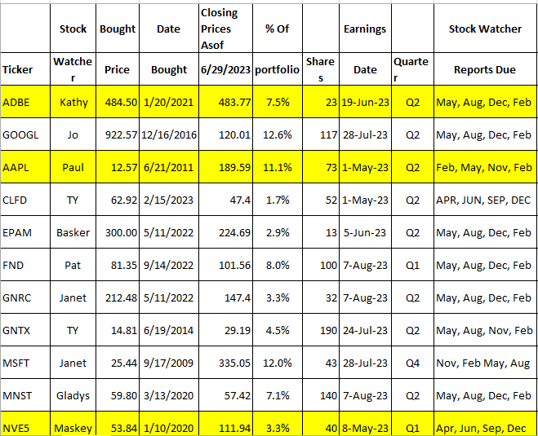
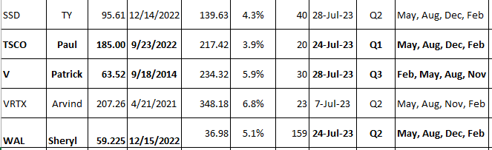

Meeting Adjourned: At 9 PM by Baskar
Minutes Submitted by Arvind Krishna; Portfolio Stocks’ Earnings Calendar updated by Maskey Krishnarao

