Model Investment Club of Northern Virginia (MicNOVA)
DC Chapter of Better Investing
Minutes for the May 09, 2023 (Online Meeting)

Members Present: Sheryl Patterson, Arvind Krishna, Ty Hughes, Gladys Henrikson, Paul O Mara, Kathy Emmons, Janet Lewis, Baskar Arumugam, Pat Onufrak
Members Absent: Maskey Krishnarao, Jo Murphy
Proxies for Members: None
Visitors/New Attendees Present: Patrick Smith, Anne Bradley, Ray Woods, Fred Beckman, Paul Doku, Sarala, Andrew Ober, Evelyn Fray, Carol Cuddihy, Lee Outlaw, Catherine Duthie, Rick Josey, Pay Woods, Bala Subramanian, AD

Baskar acted as the meeting lead. He welcomed guests including newcomers and led the meeting. He then started the meeting by explaining the club’s purpose & objectives, displayed the BI Disclaimer and explained all the clauses and stipulations.

- Secretary’s Report – Arvind
April 11, 2023 Meeting Minutes report was presented by Arvind. No corrections were addressed in the draft minutes. Gladys made the motion to accept minutes, which was seconded. The final Minutes as accepted are now posted in the Bivio folder.

- Treasurer’s Report – Gladys
Gladys presented the Treasurer’s Report indicating the availability of approximately $3000 cash available to buy stocks. Total securities and cash assets are now at approximately $110,000. Motion was made to accept Treasurer’s report and seconded. Motion passed and the Final Treasurer’s report is filed in Bivio.

The Club voted unanimously to have Ty Hughes as their new Assistant Treasurer. He replaces Pat Onufrak, who resigned the position.

Additionally, Gladys provided instructions for sending future member contributions to our new brokerage account - Charles Schwab, after June 1. The instructions are also filed in Bivio.

Gladys has been consulting with Schwab about setting up a separate MicNova – General Partnership Account. The Schwab Account Application is filed in Bivio. All Partners need to sign in the Section 10 of the application to start this account. Gladys would like to submit all the paperwork to Schwab by June 9, 2023.

- New Member Induction - Patrick Smith - has attended three MicNova Meetings, took Sheryl's SSG Class in March 2023, belongs to Better Investing, and introduced himself. He has applied for membership in MicNova. Gladys emailed his application to other members and asked for a vote within the next two days, also by email. Update. By Wednesday, May 10, Gladys had received a positive response from all 11 MicNova members, so Patrick has been officially elected as the 12th member of MicNova.

- Education & New Stock Presentation Timetable for 2023 – Baskar/Sheryl/Gladys
Partners are requested to identify their 2023 Education and Stock Presentation titles for the next 3 months in advance, so that Carol Cuddihy can submit them onto our BI webpage.

- Education: “First Cut Tips and What Other Clubs Do?” - by Sheryl
Sheryl Patterson presented ideas from other clubs for helping members feel more engaged in the club. She also showed how to produce a First Cut report, which she got it from Ticker Top from one of the other clubs. She stressed members to do this process consisting of 11 steps process, for which Better Investing gives our club credit. Her two parts presentations are filed in Bivio.

- New Stock Presentation: AVNET (AVT) – by Janet
Janet described where she found Avnet. AVNET is a leading global technical solutions co. with its extensive ecosystem delivering design, development & distribution of electronic components. AVT is currently undervalued and based on SSG it is a buy at below $45/share. It could be a Triple Play, since its current PE is less than its average PE. Her presentation is filed in Bivio. Janet would like to further challenge AVT with its competitors.

- Stock Watcher Quarterly Reports Presented:
- GOOG, MSFT, and V (Gladys) - all "Holds" - see current reports in Bivio
- NVEE (Sheryl/Maskey)-Buy, has been having hard times
- TSCO (Paul) – Hold, stock is overvalued
- WAL (Sheryl) – Buy, well managed co., consider to buy some more
- CLFD (Ty) - Hold (possibly buy)
- GNTX (Ty) - Hold

Stock Watchers (Please share the Online SSG with all MICNOVA members going forward)

- Watch List Stocks Review – by Gladys
Gladys made the motion for new stock AVNET presented by Janet to be added to the Watch list. The motion passed.

- Current MICNOVA Portfolio Review: by Ty
Ty’s review of the MICNOVA portfolio looked at two laggard stocks – Clearfield (CLFD) and GNTX. CLFD is currently at 1.7% of the portfolio. Its annual net sales are flat and its annual income per share is down. Large short interest on 14% of outstanding shares. He recommended to continue holding this CLFD stock.
Ty mentioned that GNTX is doing well with automobile industry and starting to recover. He recommended to continue holding GNTX.

- Decision Buys/Sells: Partners
After some discussion, Gladys made the motion and Sheryl seconded to buy 75 additional shares of WAL at market. A majority of members approved the purchase. (Update: TD Ameritrade notified us that we bought 75 shares of WAL at $26.95 on 05/10/2023)

- Member Questions and other Matters - Partners
New member application submitted by Patrick Smith. MICNOVA will review the application and respond by email. (See Patrick’s admission to MicNova as 12th member, above.)

- Next Month Meeting Reminders – June 13, 2023:
Education | Topic: What I Wish I’d Known About Investing and Inheritance | Pat
New Stock Presentation | STOCK: FACTSET | Jo
Stock Watcher Reports Due | Stock Watchers ( Please share the Online SSG with all MicNOVA members):  - AAPL,  - CLFD,  - EPAM,  - FND,  - GNRC,  - NVEE,  - SSD,  - VRTX
Portfolio Reports |  | Ty
Watch List Reports |  | Sheryl

2023 BI and Community Events & Announcements

Thursday May 11 2023 08:30 to 09:45 PM |  | Stock-up: What’s Inflation got to do with it? Register at  https://register.gotowebinar.com/register/1760488970940749151?source=biw
Tue May 16 2023 07:30 - 09:00 PM  (Third Tuesdays of Month) |  | Money Matters Book Discussion. Book: The Intelligent Investor by Benjamin Graham  https://global.gotomeeting.com/join/804623085  You can also dial in using your phone  United States: +1(646) 749-3122  One-touch: tel:+16467493122,,804623085#  Access Code: 804-623-085
Wed May 17 07:00 - 09:00 PM  (3nd Wednesdays of Month) |  | MCMC Monthly Meeting  https://global.gotomeeting.com/join/745127301  You can also dial in using your phone.  (For supported devices, tap a one-touch number below to join instantly.)  United States: +1 (872) 240-3311  - One-touch: tel:+18722403311,,745127301#  Access Code: 745-127-301
Thursday, May 18th 8-9:30 PM |  | Register for Bite of BINC (Free event) https://www.betterinvesting.org/learn-about-investing/our-events/bite-of-binc.
Saturday June 3rd 10:00 AM - 03:00 PM |  | Day 1: Virtual BINC 2023 | BetterInvesting National Convention  https://www.betterinvesting.org/binc/register (Register for both days)
 | Monday June 5 2023 07:00 - 08:15 PM | Digging into BI Magazine  Registration URL: https://register.gotowebinar.com/rt/6574788583850753036  Webinar ID:729-893-259
 | Saturday June 10th 10 AM – 03:00 PM | Day 2: Virtual BINC 2023 | BetterInvesting National Convention
Tue June 13 07:00 - 09:00 PM  (2nd Tuesdays of Month) |  | MicNOVA Monthly Meeting Online  https://global.gotomeeting.com/join/251997157  You can also dial in using your phone.  United States: +1 (312) 757-3121  Access Code: 251-997-157
Saturday, June 24th 10:30 AM – 1:00 PM  Guest Speaker: Doug Gerlach |  | Annual Meeting, 10.30 a.m.  Please join my meeting from your computer, tablet or smartphone. https://meet.goto.com/114623005  You can also dial in using your phone.  (For supported devices, tap a one-touch number below to join instantly.)  United States: +1 (646) 749-3122  - One-touch: tel:+16467493122,,114623005#  Access Code: 114-623-005

Schedule: New Stock Presentation, Planning and Monthly Meeting Chair
 | Name | Education | New Stock Presentation | Conduct MicNOVA Monthly Meeting | Conduct MicNOVA Planning Meeting
1 | Patterson, Sheryl | 5/9/23 | 2/13/24 | 12/12/23 | 12/5/23
2 | Hughes, James (Ty)* | 1/9/24 | 04/11/23 | 10/10/23 | 10/3/23
3 | Krishnarao, Maskey | 2/13/24 | 12/12/23 | 5/9/23/  Baskar | 5/2/23  Jo
4 | Krishna, Arvind | 7/11/23 | 11/14/23 | 8/8/23 | 8/1/23
5 | Arumugam, Baskar | 9/12/23 | 1/9/24 | 6/13/23 | 6/3/23
6 | Henrikson, Gladys | 10/10/23 | 7/11/23 | 1/9/24 | 1/2/24
7 | Murphy, Josephine(Jo)* | 8/8/23 | 6/13/23 | 7/11/23 | 7/4/23
8 | Emmons, Elinor(Kathy) | 4/11/23 | 3/12/24 | 9/12/23 | 9/5/23
9 | Laing, Amy | 12/12/23 | 10/10/23 | 3/12/24 | 3/5/24
10 | Onufrak, Patricia | 6/13/23 | 8/08/23 | 2/13/24 | 2/6/24
11 | O’Mara, W. Paul | 11/14/23 | 09/12/23 | 11/14/23 | 11/7/23
12 | Lewis, Janet | 3/12/24 | 5/9/23 | 4/11/23 | 4/4/23

For Future Education Topics:
See BI Ticker Talk, Stock-Up, and Learning Modules for ideas

Next 3 Months - Reminders
Jul 2023 | Education |  | Arvind
Jul 2023 | New Stock |  | Gladys
Aug 2023 | Education |  | Jo
Aug 2023 | New Stock |  | Pat
Sept 2023 | Education |  | Baskar
Sept 2023 | New Stock |  | Paul O’Mara

Schedule: Education Topics For 2023
Title | Presenter
Please go to BI Website Ticker Talk to find the best topics for your Education Schedule. Come up with ideas and provide your schedule and topic next month

MicNOVA Portfolio and Stock Watchers: Updated with closing prices as of 05/24/2023
By Maskey Krishnararo

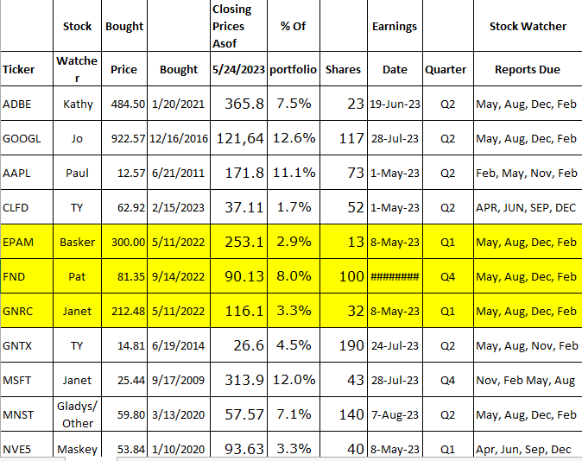

Meeting Adjourned: At 9 PM by Baskar
Minutes Submitted by Arvind Krishna; Portfolio Stocks’ Earnings Calendar updated by Maskey Krishnarao

