Model Investment Club of Northern Virginia (MicNOVA)
DC Chapter of Better Investing
Minutes for the November 08, 2022 (Online Meeting)

Members Present: Sheryl Patterson, Gladys Henrikson, Arvind Krishna, Pat Onufrak, Ty Hughes, Paul O Mara, Janet Lewis, Maskey Krishnarao, Baskar Arumugam,
Members Absent: Jo Murphy, Amy Laing, Kathy Emmons
Proxies for Members: None
Visitors Present: Paul Doku, Lee Outlaw, Fred Beckman, Carol Cuddihy, Catherine Duthie, Eveline Loyd, Robert Greensline, Anne Bradley, Eveline Lloyd, Cathy Duthie, and new attendees: Patrick Smith (onemuffin@gmail.com) and Harry Crafts (jmcrafts@verizon.net)

Paul O Mara was the meeting lead. He welcomed everyone including new visitors; explained the club’s purpose & objectives; reviewed announcements of upcoming events; displayed the BI Disclaimer; and conducted the meeting.

- Secretary’s Report – Arvind and Maskey
Oct. 11, 2022 Meeting Minutes report was presented by Arvind. Typo correction was addressed and corrected accordingly. Paul made the motion to accept minutes and Sheryl seconded. Minutes were approved. Gladys has posted the Minutes in the Bivio folder.

- Treasurer’s Report - Gladys
Gladys presented the Treasurer’s Report indicating the availability of $5,611 in cash and $64,954 in Total Securities and Cash Account. The cost for obtaining Fidelity Bond insurance ($400 per yr.) was not recommended by Pat and Gladys. Sheryl made the motion to accept Treasurer’s report and Janet seconded. Treasurer’s report was accepted by the Partners and posted in the BIVIO folder.
Gladys will try to find out more by next meeting date about how Micnova accounts, will be handled under Schwab with announced transition from the current TDAmeritrade. Hopefully, we'll be grandfathered into the merged brokerage.

- Education & New Stock Presentation Timetable for 2023: by Sheryl
Members are requested to identify their 2023 Education and Stock Presentation titles for the next 3 months in advance, so that Carol Cuddihy can submit them onto our BI webpage. Gladys suggested to make changes to the current roster if anyone has an alternative.

- Education – BI - Risk Adjusted Return Analysis - by Paul
Paul presented an excellent BI educational series on how to do Risk Adjusted Return Analysis for a stock under consideration. Risk is defined in terms of the possibility of suffering harm or loss. He defined Alpha, Beta and Standard Deviation measurements aspects of assessing risk. He explained CAPM and what Sharpe Ratio and Treynor Ratio mean and how they are computed for a potential stock under consideration.

- New Stock Presentation (PayPal - PYPL) – by Arvind
Arvind presented a comprehensive analysis of new stock PYPL. It operates a technology platform that enables digital payments on behalf of merchants and consumers worldwide. PYPL provides payment solutions under the PayPal, PayPal Credit, Braintree, Venmo, Xoom, Zettle, Hyperwallet, etc. and allows consumers/Merchants to send and receive payments in approximately 200 markets & in approximately 100 currencies. SSG analysis showed BUY range from $67 - $87. Total Return at high P/E is 14.5 and Projected Return at avg. P/E is 10.9. Stock looks promising at the current price (11/8/22) of $81. Decision was made to put PYPL on Watch List.

- Stock Watcher Quarterly Reports Presented:
- Generac (Ty) - price dropped due to a pending law suit. GNRC is a HOLD – Ty made a presentation analyzing the GNRC Stock financials and recommended that the club should hold it for the next two Qtrs. and continue watching.
- Microsoft (Janet) - it is a Buy for individual investors, but, because we have so much in our portfolio, a Hold for MicNova
- NVEE (Sheryl) - Stock is a Buy. Recommended Hold
- Visa (Gladys) - Stock is a Buy. Recommended Hold
- Adobe – (Kathy) was absent, so this report needs to be presented at the Dec meeting

Stock Watchers (Please share the Online SSG with all MICNOVA members going forward)

- Watch List Stocks Review – by Sheryl
We are searching for stocks with a PAR <10; Quality <70, and Growth < 8.
Based on this criteria, Sheryl identified 3 stocks on the watch list for which these MicNova Members will produce a new SSG for the December Meeting:
- Fox Factories – Sheryl will do
- InMode – Sheryl (Removed stock from Watch List because of tax complications with a foreign company)
- Simpson Mfg. - Ty
- Western Alliance Banks – Gladys
- Intel is in the bottom of the list
- PayPal (PYPL) added to Watch List
- Decision Buys/Sells: Partners
No buys and sells during this meeting. Keep an eye on Adobe, Century Communities, Intel, which are underperforming.

- Member Questions and other Matters - Partners
No questions and / comments raised

- Next Month Meeting Reminders – Dec 13, 2022:
Education | Analysts’ Consensus using Sheryl’s Spreadsheet | Amy
New Stock Presentation |  | Maskey
Stock Watcher Reports Due (reports may be divided between next two meetings) | - Adobe (Due from last month)  - AAPL  - CBOE  - Google/Alphabet  - EPAM  - VRTX  - Monster  - GNTX (Paul has 3 stocks – can someone volunteer for this?)  - FND (Pat's request for FND postponement until Jan 2023)  - TSCO | Kathy  Paul  Maskey  Jo  Baskar  Arvind  Amy  Paul  Pat  Paul
Portfolio Reports
Watch List Reports |  | Sheryl

2022 BI and Community Events & Announcements

Tue Nov 15 2022 07:30 - 09:00 PM  (Third Tuesdays of Month) | Money Matters Book Discussion. Get Good with Money: Ten Simple Steps to Becoming financially whole by Tiffany Aliche. 2021.  Online via GTM: You can also dial in using your phone.  United States: +1(646) 749-3122  One-touch: tel:+16467493122,,804623085#  Access Code: 804-623-085
Wed Nov 16 07:00 - 09:00 PM  Wed Dec 21 07:00 - 09:00 PM  (3nd Wednesdays of Month) | MCMC Monthly Meeting  https://global.gotomeeting.com/join/745127301  You can also dial in using your phone.  (For supported devices, tap a one-touch number below to join instantly.)  United States: +1 (872) 240-3311  - One-touch: tel:+18722403311,,745127301#  Access Code: 745-127-301
Mon Dec 5 2022 07:00 - 08:15 PM | Digging into BI Magazine  Registration URL: https://register.gotowebinar.com/rt/6574788583850753036  Webinar ID:729-893-259
Fri Dec 2 2022 08:00 - 09:00 PM | DC Chapter Monthly Meeting
Tue Dec 13 07:00 - 09:00 PM  (2nd Tuesdays of Month) | MicNOVA Monthly Meeting Online

Schedule: New Stock Presentation, Planning and Monthly Meeting Chair
 | Name | Education | New Stock Presentation | Conduct MicNOVA Monthly Meeting | Conduct MicNOVA Planning Meeting
1 | Patterson, Sheryl | 5/9/23 | 10/11/2022 | 12/13/2022 | 12/6/2022
2 | Hughes, James (Ty)* | 1/10/23 | 04/12/2022 | 10/11/2022 | 10/4/2022
3 | Krishnarao, Maskey | 2/14/23 | 12/13/2022 | 5/9/23 | 5/2/2023
4 | Krishna, Arvind | 7/11/23 | 11/8/2022 | 8/8/2023 | 8/1/2023
5 | Arumugam, Baskar | 9/13/22 | 1/10/2023 | 6/13/2023 | 6/3/2023
6 | Henrikson, Gladys | 10/11/22 | 8/8/23 | 1/10/2023 | 1/3/2023
7 | Murphy, Josephine(Jo)* | 8/8/23 | 6/13/2023 | 7/11/2023 | 7/4/2023
8 | Emmons, Elinor(Kathy) | 4/11/23 | 3/14/2023 | 9/13/2022 | 9/6/2022
9 | Laing, Amy | 12/13/22 | 2/14/2023 | 3/14/23 | 3/7/23
10 | Onufrak, Patricia | 6/13/23 | 7/11/2023 | 2/14/2023 | 2/7/2023
11 | O’Mara, W. Paul | 11/8/22 | 09/13/2022 | 11/8/2022 | 11/1/2022
12 | Lewis, Janet | 3/14/23 | 5/9/23 | 4/11/2023 | 4/4/2023

For Future Education Topics:
See BI Ticker Talk, Stock-Up, and Learning Modules for ideas

MicNOVA Portfolio Updated with closing prices as of Nov 30, 2022
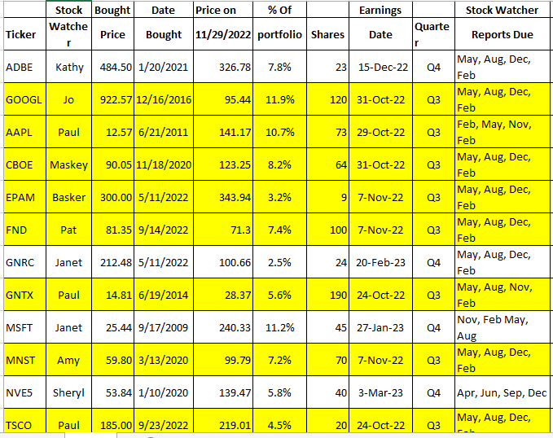
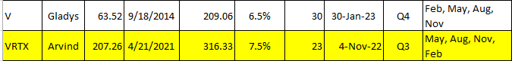

Meeting Adjourned: Paul
Minutes Submitted by Arvind Krishna; Portfolio Stocks’ Earnings Calendar updated by Maskey Krishnarao

