Model Investment Club of Northern Virginia (MicNOVA)
DC Chapter of Better Investing
Minutes for the October 11, 2022 (Online Meeting)

Members Present: Jo Murphy, Sheryl Patterson, Gladys Henrikson, Arvind Krishna, Pat Onufrak, Ty Hughes, Amy Laing, Kathy Emmons, Paul O Mara, Janet Lewis.
Members Absent: Maskey Krishnarao, Baskar Arumugam,
Proxies for Members: None
Visitors Present: Lee Outlaw, Fred Beckman, Carol Cuddihy, Carmen Dudley, Anne Bradley, NG, NS Aasad.

Ty Hughes was meeting lead. He welcomed everyone including new visitors; explained the club’s purpose & objectives; reviewed announcements of upcoming events; displayed the BI Disclaimer; and conducted the meeting.

- Secretary’s Report – Arvind
Sept. 13, 2022 Meeting Minutes report was presented by Arvind. No additional corrections were addressed. Ty made the motion to accept minutes and Jo seconded. Minutes were approved. Gladys has posted the Minutes in the Bivio folder.

- Treasurer’s Report - Gladys
Gladys presented the Treasurer’s Report indicating the availability of $5,000 in cash. Treasurer’s reported was accepted by the Partners and posted in the BIVIO folder.

- New Stock Presentations (InMode - NYSE--INMD): by Sheryl
Sheryl presented InMode, Ltd.; A Israeli Company; Sector: Health Care; and Industry: Healthcare Equipment. INMD manufactures and commercializes innovative, minimally invasive aesthetics and wellness solutions, with strong brand recognition. INMD technology is based on its proprietary radiofrequency assisted lipolysis and deep subdermal fractional radiofrequency technologies in the United States and internationally. SSG showed a BUY from $22.6 - $32.90. Total Return (High P/E): 15.5% and Projected Return (Avg. P/E): 7.3%

- New Stock Presentation (Fox Factory - FOFX) – by Ty
Ty made the presentation for road vehicles and trucks, all-terrain vehicles (ATVs), snowmobiles, specialty vehicles and applications, motorcycles and commercial trucks. SSG showed that FOFX current price is at $82.44 in the “Buy” zone.

- Education – What is new in BI on-line tools: portfolio reports and SSG audit function - by Gladys
Gladys presented the above educational session (Adapted from Suzi Artzberger’s BI Online Presentation, “What’s New in Online Tools,” August, 2022; located under “Learning Center/Video Learning Library/Online Tools”). This presentation is meant to help us fine tune both our judgement of a stock and determine if a stock is worthy of pursuing.

Informative FOXF – Sector: Consumer discretionary; Industry: Auto parts. A small business - Mid Cap stock. FOFX has two business groups – (1) makes high-performance shock absorbers for OEMs and aftermarket – a leader in a niche market. (2) Its products are used primarily on bicycles, side-by-side vehicles, on-road & off-
- Presentation on Market Update: by Ty
Ty presented “Market Update Charts” as of Oct 11, 2022 for the following:
  - S&P 500 Large Cap Index
  - Large Cap Growth vs Mid-Cap vs Small-Cap (Year to Date)
  - SPDR S&P 500ETF, NYSE
  - SPDR S&P MIDCAP 400ETF, NYSE
  - SPDR S&P Small Cap 600ETF, NYSE
  - S&P Earnings
  - CBOE 10 yr. Treasury Yield Index

- Stock Watcher Quarterly Reports Presented: None

NOTE: Stock Watcher Changes in assignments:
Floor & Decor - Pat Onufrak (new)
Gentex - Ty (added from Paul's list)
Tractor Supply Company - Paul (added, replaces Gentex)

Stock Watchers (Please share the Online SSG with all MICNOVA members going forward)

- Watch List Stocks Review – by Sheryl
It was decided to put In-Mode and FOXF in the Watch List for the November MICNOVA meeting

- Decision Buys/Sells: Partners
No buys and sells during this meeting. Keep an eye on Adobe, which is underperforming.

- Member Questions and other Matters - Partners
Lee Outlaw discussed the use of Projected Revenue and Projected EPS figures given for long term projections (2023-2026) from the Value Line for developing our forecasts for these figures to be included into the SSG.

- Next Month Meeting Reminders – Nov 08, 2022:
Education | Analyzing Risk Adjusted Returns | Paul
New Stock Presentation | PayPal | Arvind
Stock Watcher Reports Due | Adobe  CBOE  EPAM  VRTX  Monster | Kathy  Maskey  Baskar  Hold for DEC.  Hold for DEC.
Portfolio Reports
Watch List Reports

2022 BI and Community Events & Announcements

Mon Oct 17 07:00 - 08:15 PM | “DC Series Education Series: Case for growing dividends” by Craig Braemer (See Website link for registration)
Tue Oct 18 2022 07:30 - 09:00 PM | Money Matters Book Discussion.  Book Title: The Contrarian  https://global.gotomeeting.com/join/804623085  You can also dial in using your phone.  (For supported devices, tap a one-touch # below to join instantly.)  United States: +1 (646) 749-3122  - One-touch: tel: +16467493122,,804623085#  Access Code: 804-623-085
Wed Oct 19 07:00 - 09:00 PM | MCMC Monthly Meeting  https://global.gotomeeting.com/join/745127301  You can also dial in using your phone.  (For supported devices, tap a one-touch # below to join instantly.)  United States: +1 (872) 240-3311  - One-touch: tel:+18722403311,,745127301#  Access Code: 745-127-301
Mon Nov 7 2022 07:00 - 08:15 PM | Digging into BI Magazine  Registration URL: https://register.gotowebinar.com/rt/6574788583850753036  Webinar ID:729-893-259
Tue Nov 8 07:00 - 09:00 PM | MicNOVA Monthly Meeting Online  https://global.gotomeeting.com/join/251997157  You can also dial in using your phone.  (For supported devices, tap a one-touch # below to join instantly.  United States: +1 (312) 757-3121  - One-touch: tel:+13127573121,,251997157#  Access Code: 251-997-157
Tue Nov 15 07:30 - 09:00 PM | Money Matters Book Discussion.  Book Title: Get Good with Money: Ten Simple Steps to becoming financially whole  https://global.gotomeeting.com/join/804623085  You can also dial in using your phone.  (For supported devices, tap a one-touch # below to join instantly.)  United States: +1 (646) 749-3122  - One-touch: tel: +16467493122,,804623085#  Access Code: 804-623-085
Wed Nov 16 07:00 - 09:00 PM | MCMC Monthly Meeting  https://global.gotomeeting.com/join/745127301  You can also dial in using your phone.  (For supported devices, tap a one-touch # below to join instantly.)  United States: +1 (872) 240-3311  - One-touch: tel:+18722403311,,745127301#  Access Code: 745-127-301

Schedule: New Stock Presentation, Planning and Monthly Meeting Chair

 | Name | Education | New Stock Presentation | Conduct MicNOVA Monthly Meeting | Conduct MicNOVA Planning Meeting
1 | Patterson, Sheryl | 5/9/23 | 10/11/2022 | 12/13/2022 | 12/6/2022
2 | Hughes, James (Ty)* | 1/10/23 | 04/12/2022 | 10/11/2022 | 10/4/2022
3 | Krishnarao, Maskey | 2/14/23 | 12/13/2022 | 5/9/23 | 5/2/2023
4 | Krishna, Arvind | 7/11/23 | 11/8/2022 | 8/8/2023 | 8/1/2023
5 | Arumugam, Baskar | 9/13/22 | 1/10/2023 | 6/13/2023 | 6/3/2023
6 | Henrikson, Gladys | 10/11/22 | 8/8/23 | 1/10/2023 | 1/3/2023
7 | Murphy, Josephine(Jo)* | 8/8/23 | 6/13/2023 | 7/11/2023 | 7/4/2023
8 | Emmons, Elinor(Kathy) | 4/11/23 | 3/14/2023 | 9/13/2022 | 9/6/2022
9 | Laing, Amy | 12/31/22 | 2/14/2023 | 3/14/23 | 3/7/23
10 | Onufrak, Patricia | 6/13/23 | 7/11/2023 | 2/14/2023 | 2/7/2023
11 | O’Mara, W. Paul | 11/8/22 | 09/13/2022 | 11/8/2022 | 11/1/2022
12 | Lewis, Janet | 3/14/23 | 5/9/23 | 4/11/2023 | 4/4/2023

For Future Education Topics:
See BI Ticker Talk, Stock-Up, and Learning Modules for ideas

MicNOVA Portfolio Updated with closing prices as of Oct 31, 2022
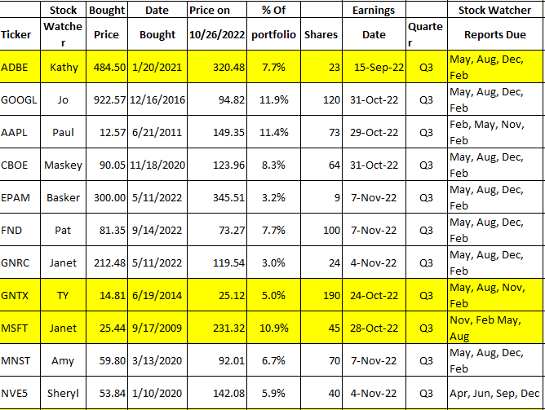
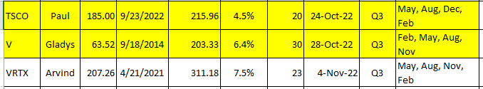

Meeting Adjourned: Ty Hughes
Minutes Submitted by Arvind Krishna; Portfolio Stocks’ Earnings Calendar updated by Maskey Krishnarao

